自己跑出来的ntu数据集结果

cross-view:

joint:

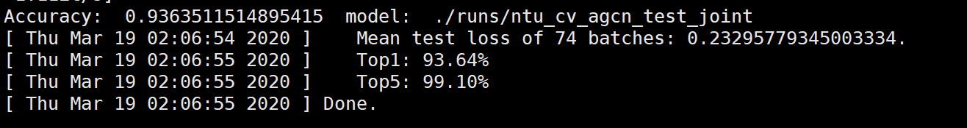

bone:

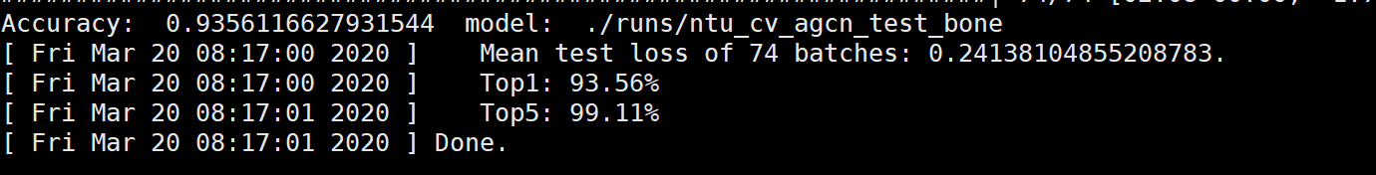

ensemble:



cross-subject

joint:



bone:

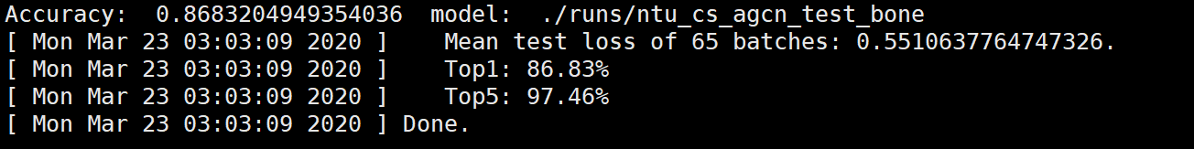

ensemble：

